# Press Release:

## COOPERATE: A role model for Europe

The Netherlands and Denmark are both at the top of EU’s Innovation Scoreboard. It highlights the importance of a European Innovation Ecosystem, with Horizon Europe as a powerful enabler. The idea behind COOPERATE is to share the experiences and learnings with other EU countries on how to build local collaboration.

A vibrant ecosystem is an essential condition for growth, and with COOPERATE the aim is to pilot the European Research Area (ERA)-Hub concept with a limited number of ecosystems and help provide a toolkit of best practices and activities that ensure a strong basis for a potential scale-up in different geographies across the EU territory in the next phase.

The European project COOPERATE kick-off meeting was held on 18-19 Jan 2023 in Eindhoven, Netherlands. All partners were represented and developed a common understanding of the ambitions with the project funded by the European Commission’s Horizon Europe Research and Innovation Program. The consortium is a 30-month project that will design, test and implement the ERA Hubs concept.

COOPERATE will define the ERA Hubs concept through co-creation arenas gathering quadruple helix actors from diverse ecosystems and develop a platform to foster collaboration and knowledge exchange across regions, sectors and disciplines. The pilot phase will test the approach in three ecosystems across Europe to refine and consolidate the framework.

The consortium is composed of 7 partners from DTU Skylab, Science City Lyngby, Czech Technical University in Prague, IDEA Consult, STAM S.r.l., Brainport Eindhoven, and the European Commission.

**Photo:**

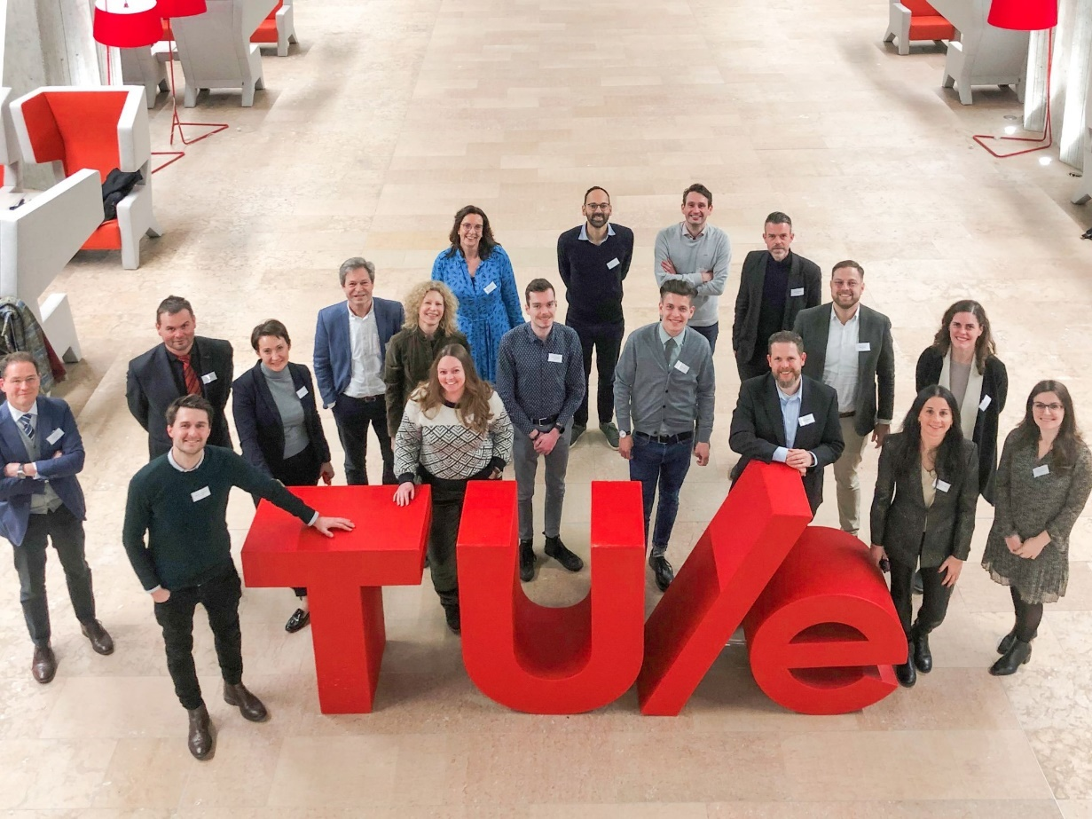

**For more information, please contact:**

Mr. Kevin van Lierop

Project lead COOPERATE communication and dissemination

06 29 49 25 01

[k.vanlierop@brainportdevelopment.nl](mailto:k.vanlierop@brainportdevelopment.nl) or [info@cooperate-project.eu](mailto:info@cooperate-project.eu)

<https://www.cooperate-project.eu/>