Grant Agreement number: 101095017
Project acronym: COOPERATE
Project coordinator: TU/e
Project title: COOrdinating and Piloting actions towards ERA-hubs as inTer- and intra-regional Ecosystems for knowledge production

CALL FOR CHAMPIONS
COOPERATE PROJECT

Annex I – Questionnaire

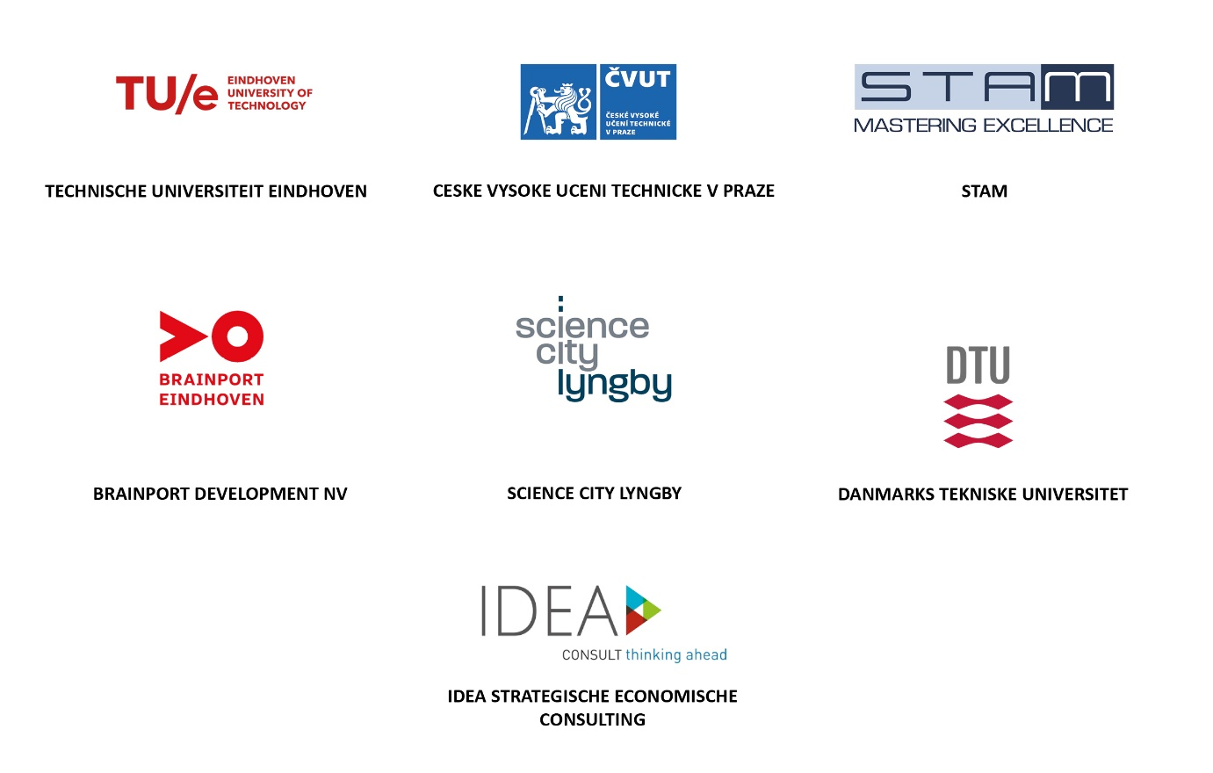

 | Funded by the European Union. Views and opinions expressed are however those of the author(s) only and do not necessarily reflect those of the European Union or the European Research Executive Agency. Neither the European Union nor the granting authority can be held responsible for them.

Please provide the information requested below.
All the information must be provided in English.

Applicant information
INFORMATION REQUIRED | DATA PROVIDED BY THE APPLICANT
Region of the ecosystem
Country
Name of the institution applying to this Call
Is the applicant a university or an organisation with close links with it and active in the knowledge valorisation field? | Yes ☐  No ☐
Main topic orientation/thematic focus of the ecosystem  (e.g. agro-food, cancer, semiconductors, artificial intelligence, etc.) | Word limit: 50

Contact
Please provide the ecosystem contact details
Name
Position
Email address

Evaluation criteria

- Please indicate the names and types of organisations that are present in your ecosystem (i.e. within the topic orientation indicated above) and that would be interested in participating in the piloting activities
Name of the organisation
Universities ☐

Business / industry ☐

Civil society organisations ☐

National government ☐

Regional government ☐

Local government ☐

- How would you describe the interaction and collaboration between these types of organisations in your ecosystem (in activities related to the topic orientation indicated above)?

☐ | ☐ | ☐ | ☐
Non-existent  There is no or little interaction between the local actors involved in knowledge production, transfer and exploitation | Emerging  There is some interaction between the local actors involved in knowledge production, transfer and exploitation but the coordination and development of joint activities is limited and requires further development. | Mature  There is interaction and coordination between the local actors involved in knowledge production, transfer and exploitation in the delivery of joint activities but there are major points requiring improvement | Advanced  There is fluid interaction and coordination between the local actors involved in knowledge production, transfer and exploitation in the delivery of joint activities

- Please provide examples of actions/activities in the field of knowledge valorisation carried out in your ecosystem (i.e. related to the topic orientation indicated above)
This can include, for instance: the existence of a knowledge or technology transfer organisation or team, activities specifically focused on knowledge exchange and valorisation across sectors and organisations, etc.
Word limit: 500

- Please provide examples of the type of collaboration and activities that are available within the ecosystem along each of the following lines of actions (related to the topic/thematic focus of the ecosystem indicated above)
Word limit: 500

Talent
(E.g. Skills development programmes, trainings, mentoring programmes, job placement opportunities)

Research
(E.g. Interdisciplinary research centres, infrastructure for R&I collaboration: e.g. labs, prototype development infrastructure, incubators, etc.)

Knowledge Transfer
(E.g. Academia-industry programmes, communication channels, workshops, hackathons, etc.)

Governance
(E.g. Formal agreements between organisations to facilitate knowledge transfer)

Funding
(E.g. Funding programmes fostering knowledge valorisation)

Innovation
(E.g. Support or mentoring programmes for startups)

- Please explain how the ecosystem presents potential for growth
This refers to the results/benefits that would be expected from achieving a higher level of collaboration between the organisations present in the ecosystem.
This can include the expected benefits/advantages that each type of organisation could obtain from a greater level of collaboration, and/or the expected benefits at ecosystem level (a better positioning and visibility in the R&I landscape, increased R&I performance, increased competitiveness of the local industry, etc.)
Word limit: 500

