Grant Agreement number: 101095017
Project acronym: COOPERATE
Project coordinator: TU/e
Project title: COOrdinating and Piloting actions towards ERA-hubs as inTer- and intra-regional Ecosystems for knowledge production

CALL FOR CHAMPIONS
COOPERATE PROJECT

Annex II – Privacy statement

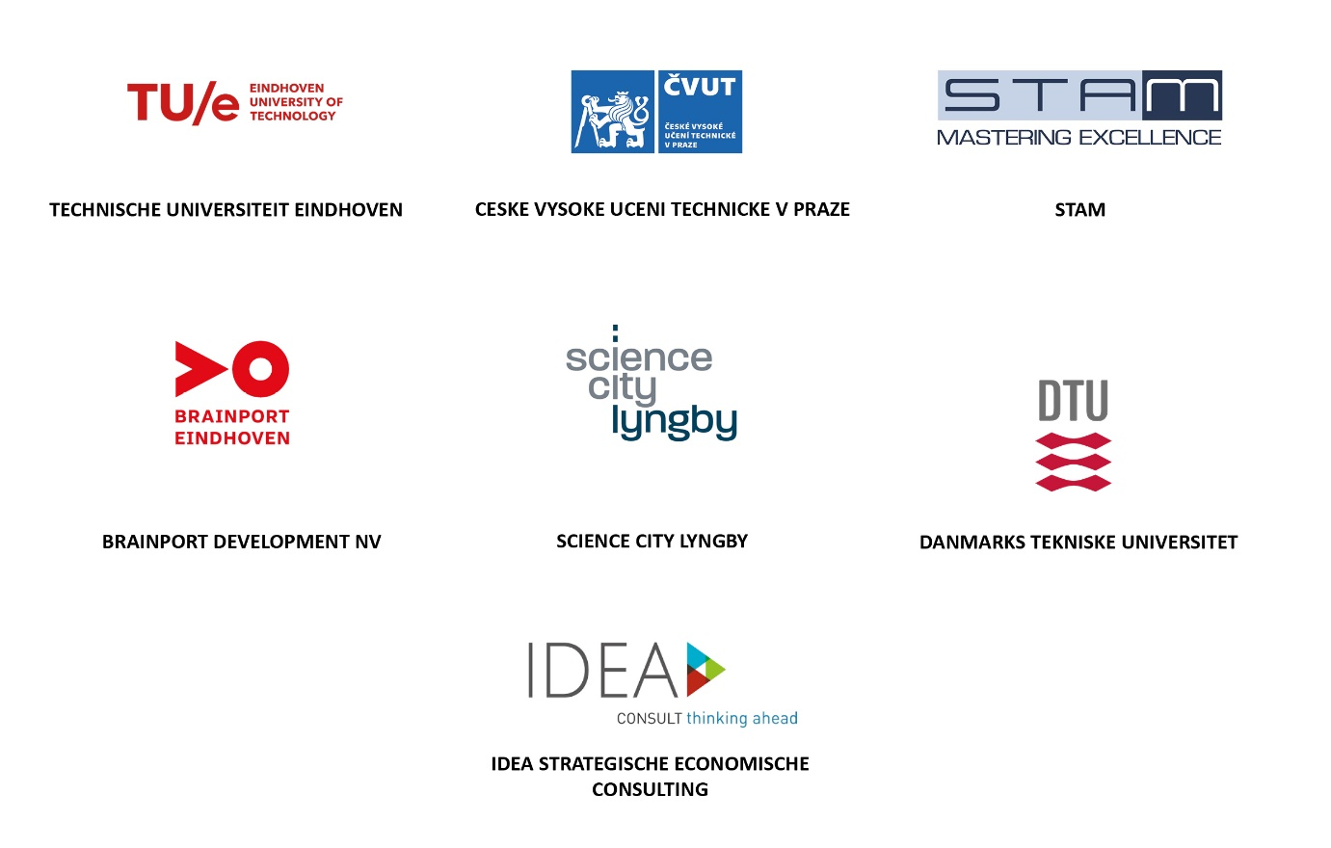

 | Funded by the European Union. Views and opinions expressed are however those of the author(s) only and do not necessarily reflect those of the European Union or the European Research Executive Agency. Neither the European Union nor the granting authority can be held responsible for them.

Contact
Please provide the ecosystem contact details as for Annex I of the “Call for Champions”
Name
Position
Email address

Privacy statement
Could you confirm your agreement to abide to the GDPR requirements of COOPERATE project?
Please tick one of the following options.
☐ YES
☐ NO

